EXPERIMENT 4: SEQUENCE DETECTOR ANALYSIS

Objectives
Understanding Mealy and Moore machine analysis of a sequence detector and compare the results.

Introduction
A three-input-length - (010) sequence detector (as a Moore and also a Mealy machine) will be examined.

Preliminary Work
We wish to design a circuit which detects separate (010) sequences in a string of bits coming through an input line (i.e., the input is a serial bit stream). Once the (010) sequence is detected, output becomes (1), otherwise it stays as (0). A sample input and output bit streams (sequence) are given below. First bit coming to the input is the one shown on the left.
time

Example Input stream: 00100101010010
Example Output stream: 00010010001001

Two realizations of the above sequence detector are given below.

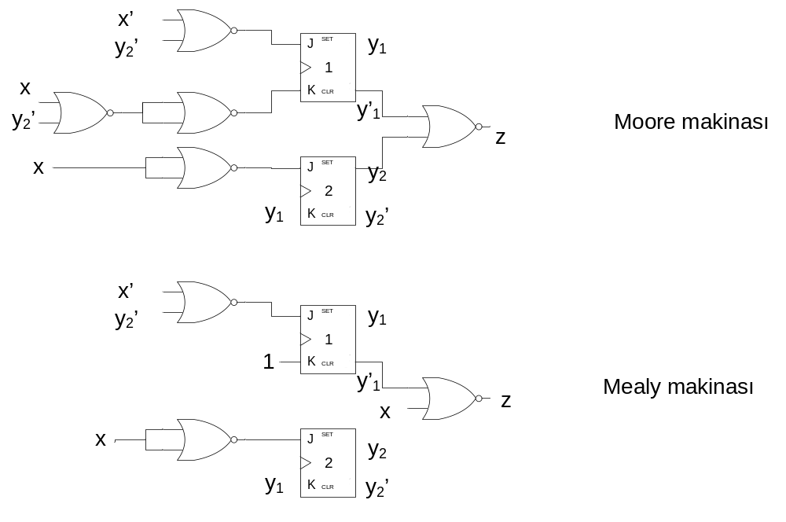

Before coming to LAB:
- Find the state diagrams of this sequence detectors a) as a Mealy machine b) as a Moore machine.
- Simulate your Moore and Mealy realizations on proteus for the above given example input stream.

Procedure:
- Set up the above given Mealy machine on your board.
- Do not forget power and ground connections.
- Use standard switches (TTL SWT) for preset and clear control inputs to as required.
- Use a standard switch (TTL SWT) for the x input.
- Use negative pulsar switch for clock input.
- Use LED s for states and z output observation.
- Verify your Mealy machine realization on bread board with state diagram you found in prelab work.
- Apply the above given sample input bit stream (sequence) and observe output stream. Compare your results with proteus graphical result.
- Draw time diagrams for the (x) input, (y₁, y₂) state variables and z output on a separate sheet given below.
Attention:
- For each input there should be a clock pulse (In this case 13 pulses required)
- Initial state: 00 should be arranged by preset and clear inputs. You have to rearrange above example input stream right after initial state has been applied.

Required components: 7476 JK FF, 7402 NOR gates IC

EXPERIMENT 3 REPORT: SEQUENCE DETECTOR

Date: Session: Group
Student
Name: Name: Name:
Surname Surname Surname

Questions
- Could there be any unexpected faulty output that you could observe at the output bit stream of this Mealy machine you realized.
  - If your answer is yes, give an input sequence which gives an unexpected (hazardous) faulty output (zararlı hatalı çıkış).
  - If your answer in NO, Is it worth to choose Moore realization instead of Mealy?
- If you change the above chosen state assignment with another one, will you still have a valid design? Why?
- How would state-assignment-change affect a sequential design? Does it affect the number of FF s? Why?
- Could we choose any state as an initial state? Why?
- Can we say Moore machine is always preferable since there won’t be any false outputs?

